The traditional IBP method is all very well, and works fine. So why am I interested in another method for doing the same thing? Well actually, I’m not. I’m just advocating a different way of looking at IBP: a visual way. A way that emphasises pattern, form and structure. A way that makes the mechanics of IBP easier to control. A way that reduces the number of mistakes you make. And a way that can offer an insight into many other areas of mathematics than just integration. Sound good? So, by way of an introduction to the tabular, “DIS”, method, let’s integrate the same I = Z x 2 sin(x) dx that we’ve just integrated the traditional way3 . Using DIS, we still have to decide on the u and the dv, and in this case the x 2 factor is the one that we want to differentiate, because it will get simpler. Integrating sin(x) will not make it any more complex. Now have a look at Figure 1 for a visual way to lay out the problem.
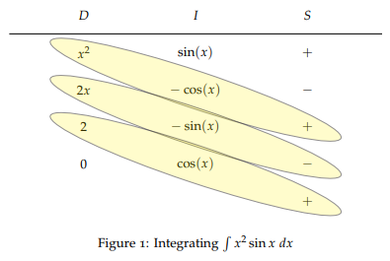

We have a table with three columns, labelled D, I and S. The D column represents Differentiation, the I column represents Integration, and the S column represents Sign (that is, + or −). We’re going to put the x 2 at the top of the D column (because we’ve decided to differentiate the x 2 ), and because it’s in the D column we keep differentiating it, row after row, in this case until we get 0. We put the sin(x) at the top of the I column. And because it’s in the I column we keep integrating it, row after row, in this case until we get down to the line opposite 0 in the D column. The signs in the S column just keep alternating, starting with a +. Once you’ve filled in the table, mark off the diagonals, starting with the top-left entry in the table, as shown in Figure 1. And we’re nealy done! To find the integral, we just read down the diagonals and multiply the D entry by the I entry by the S entry for each diagonal to give exactly the same result (thankfully!)

